

# NATIONAL UNIVERSITY OF SCIENCES AND TECHNOLOGY

SCHOOL OF MECHANICAL AND MANUFACTURING ENGINEERING

MECHANICAL ENGINNERING (ME-15)

# PROGRAMMING:

Home task #3

**SUBMITTEED BY: MUHAMMAD ALI SHOUKAT**

**REGISTRATION NUMBER: 457397**

DATE OF SUBMITTION: 16th of October, 2023

//#include<iostream>

//using namespace std;

int main(){

//**task 1:**

//char population;

//int p,s,k,b;

//cout<<"press a for punjab,b for sindh,c for kpk and d for balochistan\n ";

//cin>>population;

//p=127474000;

//s=54858515;

//k=40800000;

//b=21700000;

//switch(population){

//case'a':

//cout<<"the population of punjab is "<<p;

//break;

//case'b':

//cout<<"the population of sindh is "<<s;

//break;

//case'c':

//cout<<"the population of kpk is "<<k;

//break;

//case'd':

//cout<<"the population of balochistan is "<<b;

//break;

//}

* **Output:**

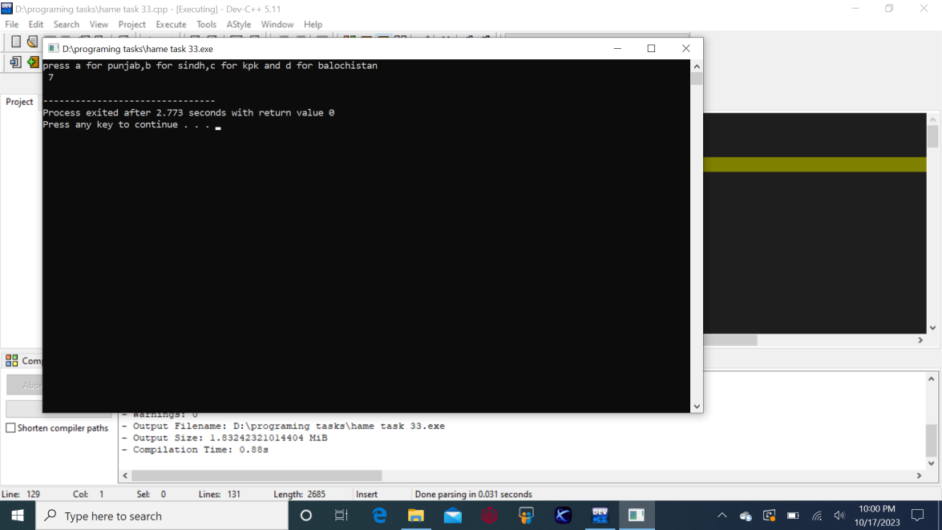

//**task 2:**

//char alphabet;

//cout<<"enter your desired alphabet\n ";

//cin>>alphabet;

//switch(alphabet){

//case'a':

//case'A':

//case'e':

//case'E':

//case'i':

//case'I':

//case'o':

//case'O':

//case'u':

//case'U':

//cout<<"the entered number is vowel";

//break;

//default:

//cout<<"the entered number is a consonant";

//break;

//}

* 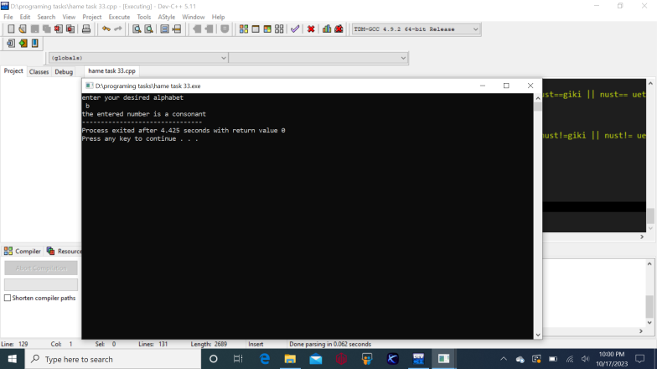**Output:**

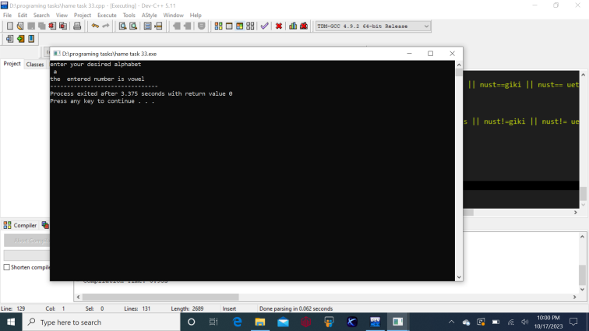

//**task 3:**

//int num;

//cout<<"enter your desired number there ";

//cin>>num;

//switch(num){

// case 0:

// cout<<"the entered number is zero ";

// break;

// default:

// if(num>=0){

// cout<<"the entered number is positive and greater than zero";

// }

// else{

// cout<<"the entered number is negative and less than zero";

//}

//}

* **Output:**

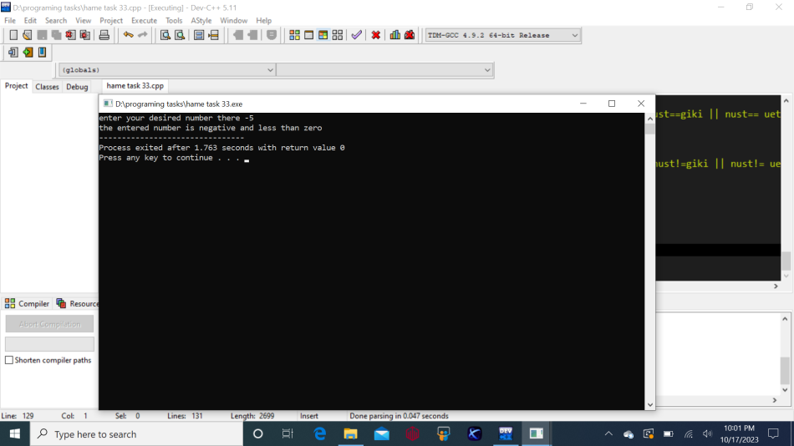

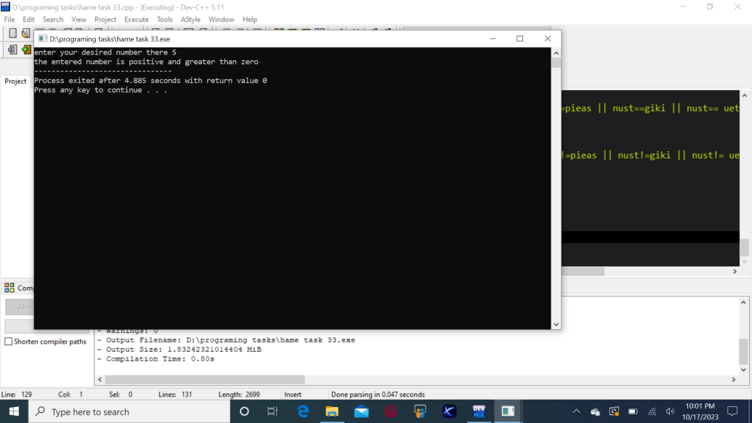 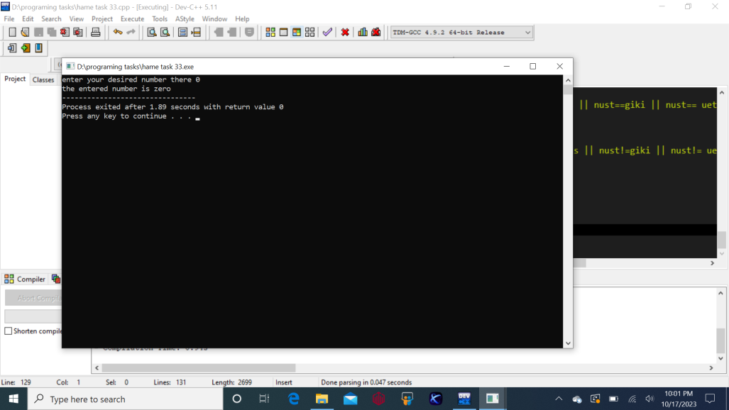

//**task 4:**

//int x;

//cout<<"enter your desired age ";

//cin>>x;

//if(x>=18){

//cout<<"the person is adult ";

//}

//else{

// if(x>=13 && x<=17){

// cout<<"the person is a teenager ";

// }

//else{

//if(x<13){

// cout<<"the person is a child ";

//}

//}

//}

* **Output:**



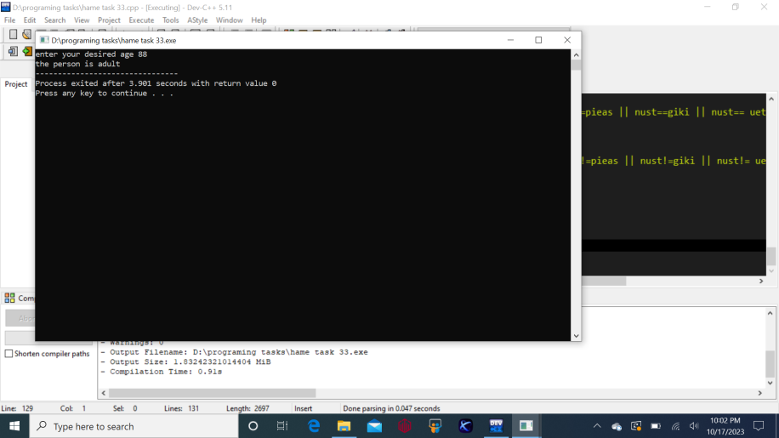 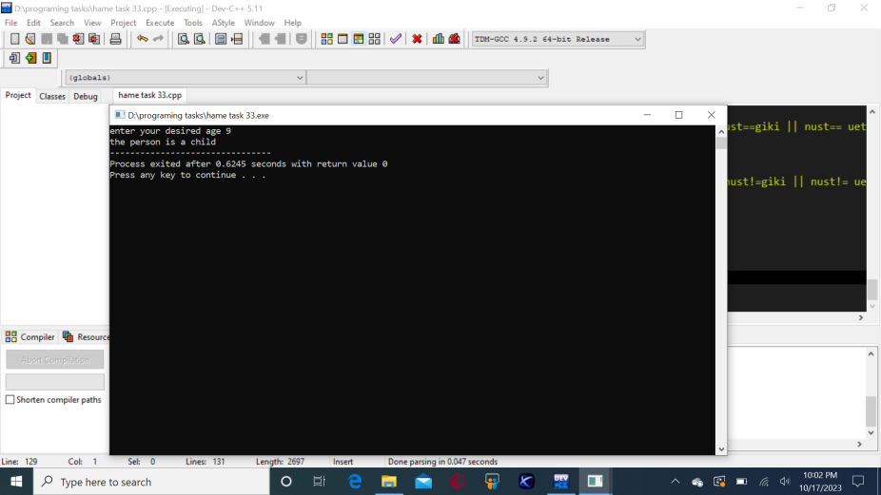 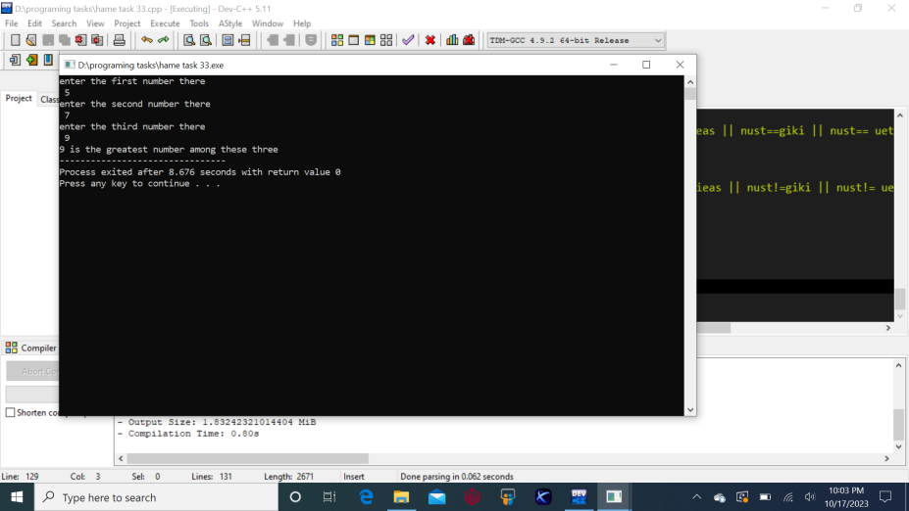

//**task 5:**

//int a,b,c;

//cout<<"enter the first number there\n ";

//cin>>a;

//cout<<"enter the second number there\n ";

//cin>>b;

//cout<<"enter the third number there\n ";

//cin>>c;

//if(a>b && a>c){

// cout<<a<<" is the greatest number among these three ";

//}

//else{

// if(b>c && b>a){

// cout<<b<<" is the greatest number among these three ";

// }

// else{

//// if(c>b && c>a){

//// cout<<c<<" is the greatest number among these three ";

//// }

//// }

////

////}

//// return 0;

//}

* **Output:**

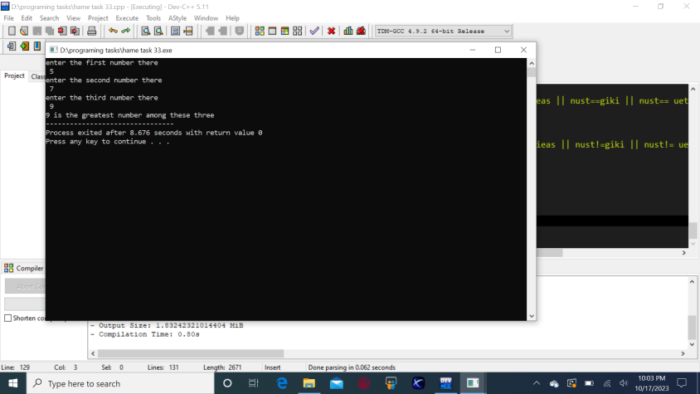

//**task 6:**

alph;

cout<<"enter your desired alphabet ";

cin>>alph;

if(alph=='a'){

cout<<"the entered alphabet is a vowel ";

}

else {

if(alph=='A'){

cout<<"the entered alphabet is a vowel ";

} else {

if(alph=='e'){

cout<<"the entered alphabet is a vowel ";

} else {

if(alph=='E'){

cout<<"the entered alphabet is a vowel ";

}else {

if(alph=='i'){

cout<<"the entered alphabet is a vowel ";

}else {

if(alph=='I'){

cout<<"the entered alphabet is a vowel ";

}else {

if(alph=='O'){

cout<<"the entered alphabet is a vowel ";

}else {

if(alph=='o'){

cout<<"the entered alphabet is a vowel ";

}else {

if(alph=='u'){

cout<<"the entered alphabet is a vowel ";

}else {

if(alph=='U'){

cout<<"the entered alphabet is a vowel ";

}else {

cout<<"the entered alphabet is a consonant ";

}

}

}

}

}

}

}

}

}

return 0;

}

}

* **Output:**

